Conference Tours
During the conference, the participants will be offered tours in Baku museums:
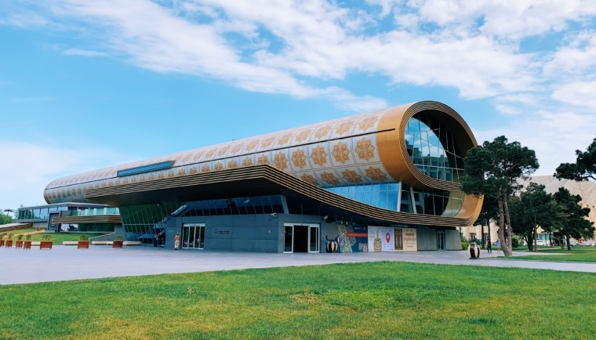
Azerbaijan National Carpet Museum (conference venue)
The Azerbaijan Carpet Museum was created under the Decree No. 130 dated March 13, 1967 of the Council of Ministers of the Azerbaijan SSR. From 1967 to 1993, the museum was called the Azerbaijan State Museum of Carpet and Folk Applied Arts, from 1993 to 2014 - State Museum of Carpet and Applied Arts named after Latif Karimov, from 2014 to the present time the Azerbaijan Carpet Museum. At the time of establishing, it was the only museum that was dedicated to the art of carpet weaving. The main purpose of the creation of the museum was to store, research, and demonstrate unique examples of the carpet weaving art, which are the Azerbaijan’s national heritage. More: http://azcarpetmuseum.az/front/en

National Museum of History of Azerbaijan
The National Museum of History of Azerbaijan is the largest museum in Azerbaijan, located in Baku, in the former mansion of Azerbaijani oil magnate and philanthropist Haji Zeynalabdin Taghiyev. It was founded in 1920 and opened to visitor in 1921. More: http://azhistorymuseum.gov.az/?lng=en
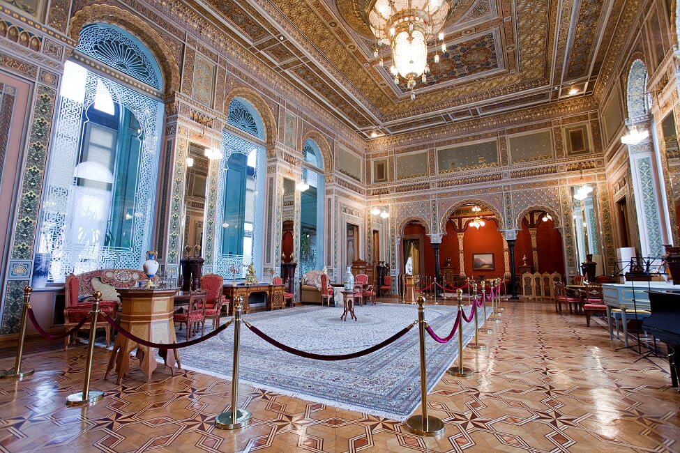

National Art Museum of Azerbaijan
National Art Museum of Azerbaijan is the biggest art museum of Azerbaijan. It was founded in 1936 in Baku and in 1943 was named after Rustam Mustafayev, a prominent Azerbaijani scenic designer and theater artist. The museum consists of two buildings standing next to each other. The museum’s total collection includes over 15,000 artworks. There are over 3,000 items in 60 rooms on permanent display. About 12,000 items are kept in storage. The museum changes the exhibits periodically so that more of these artworks can be displayed temporarily. More: http://www.nationalartmuseum.az/
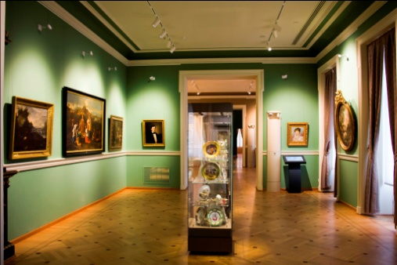

Heydar Aliyev Center
The cultural center includes an auditorium (congress center), a museum, exhibition halls, administrative offices. The project of the center was developed in 2007 by the famous architect Zaha Hadid. The opening took place on May 10, 2012. In 2014, the Heydar Aliyev Center was awarded the Design of the Year. It is considered one of the symbols of modern Baku. More: http://www.heydaraliyevcenter.az/#main
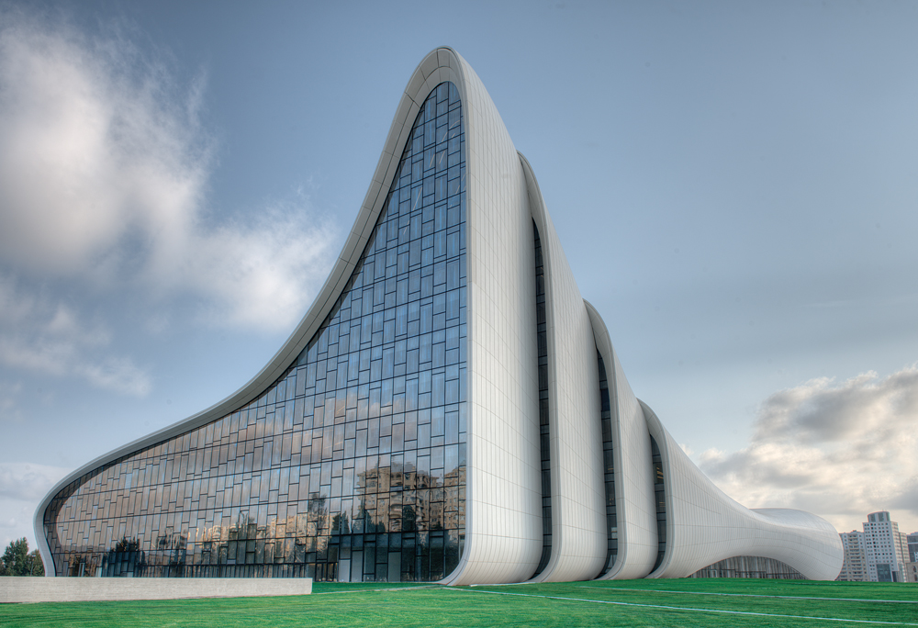

Icherisheher Museum Center
The Charter of the State Department of the Historical and Architectural Reserve of Icherisheher under the Cabinet of Ministers of the Republic of Azerbaijan was approved by a Decree of the President of the Republic of Azerbaijan on May 16, 2007 and the Department has been operating since that time. The Department was established with the aim to develop a unique management system, combining the functions and powers of central and local executive authorities in order to preserve and maintain the monuments for future generations. In December 2000, the Old City of Baku, including the Palace of the Shirvanshahs and Maiden Tower, became the first location in Azerbaijan to be classified as a World Heritage Site by UNESCO. More: https://icherisheher.gov.az/en/
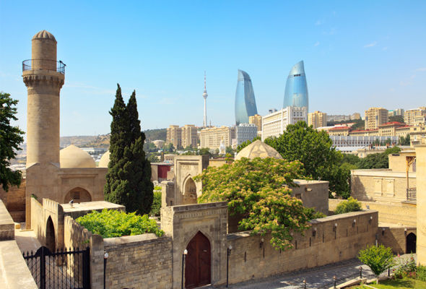

Additionally, the programme will include three options for post-conference tours:
1. Absheron (Mardakan Castle, Atashgah Fire temple, Yanardag/Burning Mountain);
Sights inscribed on UNESCO World Heritage List:
2. Gobustan National Historical-Artistic Preserve, which is famous for the ancient rock drawings;
3. Sheki, the ancient city of handicrafts (Caravanserai, Khan’s Palace).
Post-conference tours will be available for the participants and accompanying persons at additional costs. Please find below the proposed tours. The detailed programmes for each tour will be announced later.
For joining the post-conference tours, please continue to online registration form

1) A day trip to Absheron:
− Qala Archeological and Ethnographic Museum Complex
The Qala Archaeological and Ethnographic Museum Complex functioning in the open air was created in 2008 to preserve historical and archaeological objects discovered in the Absheron Peninsula. The museum demonstrates various archaeological artifacts covering the period from the 3rd-2nd millennia B.C. to the 15th century, including petroglyphs, tambourine stone, ceramics, domestic and adornment items, weapons and coins, remnants of an ancient residential complex etc.
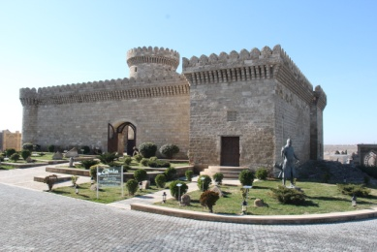

− Mardakan Castle
The Quadrangular Mardakan, or the Great Mardakan fortress is one of the oldest and tallest fortresses of Absheron. The height of the tower is 22 meters, the height of the walls is 7 meters. The thickness is 2.1 meters below the bottom and 1.6 meters from the top. Located in Mardakan settlement of Baku, Mardakan fortress was built by Shirvanshah I Akhsitan in the 12th century (1187-1188) to celebrate the glorious victory of Akhsitan over the enemy. The fortress was used as a shelter and observation point of feudals.
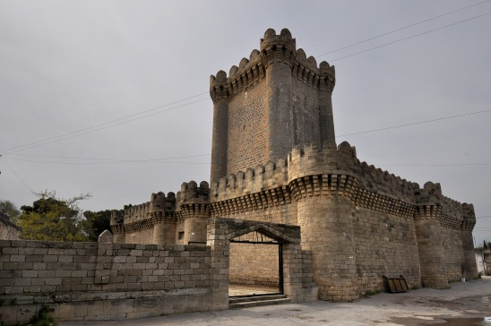

− Ateshgah - Fire Temple
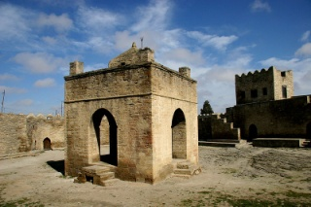
One of the most interesting and peculiar historical monuments near Baku is the fire temple of Indian fire-worshippers called Ateshgah. The history of Ateshgah goes back to the time of the Iranian Sassanids, when Zoroastrianism was the main religion in this region. The temple was constructed in the 17th by Indians came from Northern India and were members of the Sikh community. It is located not far from the sea, to the south-east of the village of Surakhani, on the Absheron Peninsula. The temple was declared a state historical-architectural reserve in 2007. Ateshgah - Fire Temple was inscribed on the UNESCO World Heritage Tentative List in Need of Urgent Safeguarding on September 30, 1998 and was granted “enhanced protection” status.

− Yanardag (burning mountain)
Yanardag (burning mountain) is a natural gas fire which blazes continuously on a hillside on the Absheron Peninsula on the Caspian Sea. Yanar Dag is located 25 km to the north from Baku, in Mehemmedi village. In 2007, Yanardag is declared as the Yanardag State Historical-Cultural and Natural Reserve. The reserve covering an area of 64.55 hectares features a 3-zoned museum, a 500-seat amphitheater for outdoor concerts, different exhibitions displaying ancient stones and pieces of craftsmanship used by locals, as well as, tombstones, ancient kurgans, 2 burial grounds with historic graves. The Yanardag flame burns fairly steadily, as it involves a steady seep of gas from the subsurface. The flames emanate from vents in sandstone formations and rise to a height of 10 metres (33 ft) at the base of a 10-metre-wide (33 ft) scarp below a hillside.
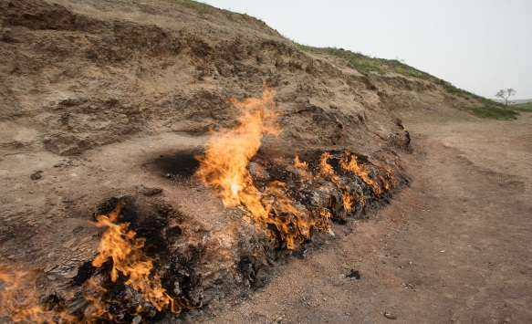

2) A day trip to Gobustan:
Gobustan National Historical-Artistic Preserve
Gobustan National Historical Artistic Preserve has been in operation since 1966. Gobustan National Park is located west of the settlement of Gobustan, about 40 miles (64 km) southwest of Baku on the west bank of the Caspian Sea.
Its outstanding collection of about 7000 rock carvings which depict people, animals, battle-pieces, ritual dances, bullfights, boats with armed oarsmen, warriors with lances in their hands, camel caravans, pictures of sun and stars, as well as 20 shelters (caves) and 40 kurgans (burial places) date back from the Upper Palaeolithic (20-15 thousand years BC.) to the Middle Ages.
The Gobustan Preserve is the one of the most popular touristic places in Azerbaijan. The Museum of the Preserve was awarded by The European Museum of the Year Award in 2013. Scientific materials have been found during exploration are exhibited through new methods and cutting edge technology in the museum. Gobustan is also a real open-air museum.
“Gobustan Rock Art Cultural Landscape” being under the enhance protection of the UNESCO was inscribed on the World Heritage List in 2007. More: http://www.gobustan-rockart.az/
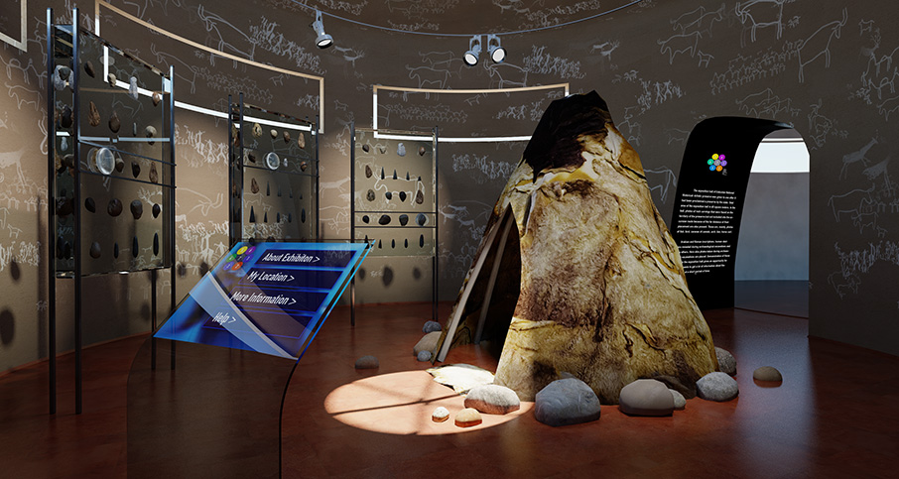

3) A two-day trip to Sheki:
− Sheki Khan's Palace
The Palace of Sheki Khans in was a summer residence for the Sheki Khans. It was built in 1797 by Muhammed Hasan Khan. The summer residence is famous for its lavish exterior and interior ornamentations. Along with its pool and plane trees, the summer residence is the only remaining structure from the larger palatial complex inside the Sheki Khans' Fortress, which once included a winter palace, residences for the Khan's family and servants' quarters. It features decorative tiles, fountains and several stained-glass windows.
The exterior was decorated with dark blue, turquoise and ochre tiles in geometric patterns and the murals were coloured with tempera and were inspired by the works of Nizami Ganjavi. The interior walls of the residence are covered entirely with frescoes painted at different times during the eighteenth century. Many of the frescoes feature flowers in vases, while a series of paintings on the first floor halls depict hunting and battle scenes.
In 2019, the Historic Centre of Sheki with the Khan’s Palace was inscribed as a UNESCO World Heritage Site.

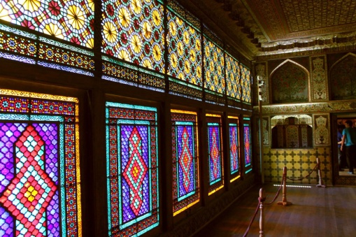
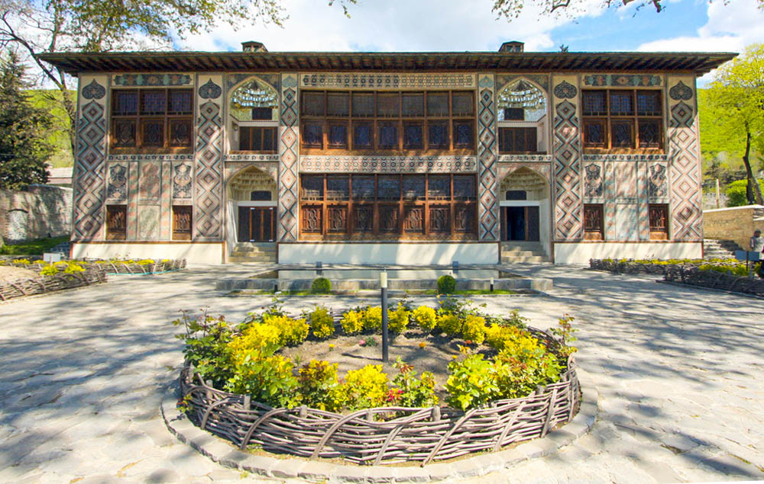

− Sheki Caravanserai
Caravanserai in Sheki is a historical monument including two magnificent caravanserais which traditionally named “Yukhary” and “Ashaghy”, or “Upper” and “Lower” Caravanserais. These caravanserais are dated back to the 18th-19th centuries. The Lower Caravanserai is used as a hotel.
