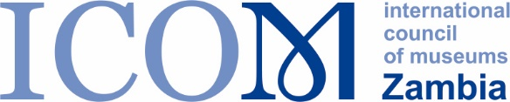 | 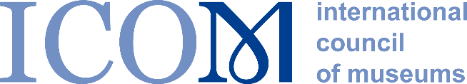

I N V I T A T I O N T O P A R T I C I P A T E
AFRICAN MUSEUM DIRECTORS MENTORING WORKSHOPS ON
COMMUNITY ENGAGEMENT AND GOVERNMENT RELATIONS

Wednesday 8 February 2023 at 15.00 CAT
and
Wednesday 15 February 2023 at 16.00 CAT

The very successful and well attended Africa Director's Forum in November 2022, led by Professor George Abungu, provided Africa's leading museum professionals with an opportunity to exchange experiences and discuss key issues facing them.
In particular, two themes emerged which are of principal concern to the participants:
- Engaging meaningfully with government and stakeholders
- How to develop an audience centred approach to community engagement
The Forum's breakout sessions were a rich source of actionable ideas and experience which came from the participants. We are keen for this experience to be shared in greater detail and it is therefore with great pleasure that we invite you to the next phase of the ICOM INTERCOM Solidarity Project LEADERSHIP ALERT – CAPACITY BUILDING FOR FUTURE MUSEUM SCENARIOS – two Africa Museum Director's Mentoring Workshops which have been organised with our delivery partners, Fundacion Typa from Argentina. The Africa Museum Director's Mentoring Workshops are free to participate in and will provide you with an opportunity to exchange ideas and experiences with other museum directors.
Online Mentoring Workshop 1 – Wednesday 8 February 2023 at 15.00 CAT (Duration: 1.5 hours)
Led by Dr Noel Lwoga, Director General of the National Museums of Tanzania and Senior Lecturer (Part-Time) in Heritage and Tourism at the University of Dar es Salaam.
Online Mentoring Workshop 2 – Wednesday 15 February 2023 at 16.00 CAT (Duration 1.5 hours)
Led by Ms Beryl Ondiek, Director of the National Museums of Seychelles
The Mentoring Workshops are focused on two key issues which came up in the Africa Director's Forum: how to engage effectively with communities and how to develop a meaningful relationship with government stakeholders. The workshops are aimed at Senior Museum Directors and relvant museum leaders and Senior Curators from a wide range of museums across Africa.
Format for the online Africa Museum Director's Mentoring Workshops
 | Wednesday 8 February 2023 |  | Wednesday 15 February 2023
5 mins | Introduction |  | Introduction
20 mins | Presentation by Dr Noel Lwoga |  | Presentation by Ms Beryl Ondiek
10 mins | Q&A in plenary |  | Q&A in plenary
15 mins | Breakout 1 - Community Engagement |  | Breakout 1 - Community Engagement
10 mins | Report back from breakout and Q&A |  | Report back from breakout and Q&A
15 mins | Breakout 2 – Government Relations |  | Breakout 2 – Government Relations
10 mins | Report back from breakout and Q&A |  | Report back from breakout and Q&A
5 mins | Conclusion and final wrap up |  | Conclusion and final wrap up

We hope to see you at the workshops!
Yours sincerely,
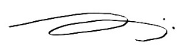
Goranka Horjan
Chair, ICOM INTERCOM
You can take part in both workshops, please specify your preference. Please fill in the participation form below and send it to: museos@typa.org.ar
AFRICAN MUSEUM DIRECTORS MENTORING WORKSHOP
PARTICIPANTS APPLICATION FORM

Name
Job Title
Email address
Museum
Country
Workshop/s in which I will take part

